

**SINHAGAD INSTITUTE OF BUSINESS ADMINISTRATION AND RESEARCH**

**(SIBAR)-PUNEDEPARTMENTOFMCA**

MASTERINCOMPUTERAPPLICATIONFROM SAVITRIBAI PHULE UNIVERSITY PUNE

KRAI:ML,DLJOURNAL ON

Subject:IT34KnowledgeRepresentationandArtificial Intelligence.

IN

MASTERINCOMPUTERAPPLICATION

SUBMITTEDBY

**ShubhamSanjayPatil(105)**

SAVITRIBAIPHULEPUNEUNIVERSITY

SINHGADINSTITUTEOFBUSINESSADMINISTRATIONANDRESEARCH KONDHWA, PUNE-411048

2022-2023

***UNDERTHESUPERVISIONOF***

***Dr.NetraPatil***

**Sinhgad Technical Education Society’sSinhgadInstituteofBusinessAdministrationandResearch**

**Kondhwa(Bk.),Pune411048**

**Subject:IT34-KnowledgeRepresentationandArtificialIntelligence:ML,DLPractical**

|  |  |  |  |  |
| --- | --- | --- | --- | --- |
| **No.** | **AssignmentQuestion** | **Page No.** | **Date** | **Sign** |
| 1 | WriteaPythonprogramtoFindthecorrelationmatrix. |  |  |  |
| 2 | Plotthecorrelationplotondatasetandvisualizegivinganoverviewofrelationships among data on iris data. |  |  |  |
| 3 | WriteaPythonprogramtopredictmpg(milespergallon)foracarbasedonvariablewt by applying simple linear regression on 'mtcars' dataset (Use Training data 80% and Testing Data 20%).  Recordtheperformance ofmodelintermsofMAE,MSE,RMSEandR-squaredvalue.  ChangeTrainingdatato70%andTestingData30%,compare&interpretthe performance of your model. |  |  |  |
| 4 | WriteaPythonprogramtopredictmpg(milespergallon)foracarbasedonvariableswt, cyl & disp by applying multi-linear regression on 'mtcars' dataset (Use Training data 80% and Testing Data 20%).  Recordtheperformance ofmodelintermsofMAE,MSE,RMSEandR-squaredvalue.  Removevariabledispfromthefeaturesetandcheckthe performanceagain.Compare& interpret the performance of |  |  |  |
| 5 | Write a Python program to predict mpg (miles per gallon) for a car based on variables wt, cyl & disp by applying multi-linear regression on 'mtcars' dataset (UseTraining data 80% and Testing Data 20%).  Recordtheperformance ofmodelintermsofMAE,MSE,RMSEandR-squaredvalue.  Replacedispbydratvariableinthefeaturesetandchecktheperformanceagain.Interpret the performance of your model. |  |  |  |
| 6 | Writea Python program to predictfruit (Apple or Orange)based onits size & weightby applying logistic regression on 'apples_and_oranges' dataset (Use Training data 80% And Testing Data 20%).  EvaluatetheperformanceofthemodelusingAccuracy Scoremetric, Classification  Report&ConfusionMatrix,AUCROCscoreforthemodelandinterpretthemodel performance. |  |  |  |
| 7 | WriteaPythonprogramtopredictfruit(AppleorOrange)basedonitssize&weight by applying K-Nearest Neighbour (KNN) model on 'apples_and_oranges' dataset (Use Training data 80% and Testing Data 20%).  EvaluatetheperformanceofthemodelusingAccuracy Scoremetric, Classification  Report&ConfusionMatrix,AUCROCscoreforthemodelandinterpretthe model performance. |  |  |  |
| 8 | WriteaPythonprogramtopredictfruit(AppleorOrange)basedonitssize&weight byapplyingSupportVectorMachine(SVM)modelon'apples_and_oranges'dataset  (UseTrainingdata80%andTestingData20%). |  |  |  |

|  |  |  |  |  |
| --- | --- | --- | --- | --- |
|  | Evaluate the performance of themodel usingAccuracy Score metric, Classification Report&ConfusionMatrix,AUCROCscoreforthemodelandinterpretthemodel performance. |  |  |  |
| 9 | WriteaPythonprogramtopredictspecies(Setosa,Versicolor,orViriginica)fora  new iris flower based on length & width of its petals and sepals by applying logistic regression model on 'iris' dataset (Use Training data 80% and Testing Data 20%).  Evaluate the performance of themodel usingAccuracy Score metric, Classification Report&ConfusionMatrix,AUCROCscoreforthemodelandinterpretthemodel performance. |  |  |  |
| 10 | Write a Python program to predict species (Setosa, Versicolor, or Viriginica) for a new irisflowerbasedonlength&widthofitspetalsandsepalsbyapplyingK-Nearest Neighbour(KNN)modelon'iris'dataset(UseTrainingdata80%andTestingData20%). Evaluate the performance of the model usingAccuracy Score metric, Classification Report & Confusion Matrix,AUC ROC score for the model and interpret the model  performance. |  |  |  |
| 11 | Write a Python program to predict species (Setosa, Versicolor, or Viriginica) for a new iris flower based on length & width of its petals and sepals by applying Support Vector Machine (SVM) model on 'iris' dataset (Use Training data 80% and Testing Data 20%). EvaluatetheperformanceofthemodelusingAccuracyScoremetric,Classification  Report&ConfusionMatrix,AUCROCscoreforthemodelandinterpretthe modelperformance. |  |  |  |
| 12 | Write a Python program to predict species (Setosa, Versicolor, or Viriginica) for a new iris flower based on length & width of its petals and sepals by applying Naive Bays Classification model on 'iris' dataset (Use Training data 80% and Testing Data 20%).  EvaluatetheperformanceofthemodelusingAccuracy Scoremetric, Classification  Report&ConfusionMatrix,AUCROCscoreforthemodelandinterpretthemodel performance. |  |  |  |
| 13 | Write a Python program to predict species (Setosa, Versicolor, or Viriginica) for a new iris flower based on length & width of its petals and sepals by applying Decision Tree model on 'iris' dataset (Use Training data 80% and Testing Data 20%).  EvaluatetheperformanceofthemodelusingAccuracyScoremetric,Classification  Report&ConfusionMatrix,AUCROCscoreforthemodelandinterpretthe modelperformance. |  |  |  |
| 14 | Write aPythonprogram toimplementtheK-meansAlgorithmonunsuperviseddata of a mall, that contains the basic  information(ID,age,gender,income,spendingscore)aboutthecustomers.Findthe clusters based on the income and spending. |  |  |  |
| 15 | Write a Python program to implement the Agglomerative Hierarchical Clustering Algorithm on unsupervised data of a mall, that contains the basic information (ID, age, gender, income, spending score) about the customers. Find the clusters based on the income and spending. |  |  |  |

|  |  |
| --- | --- |
| 1 | WriteaPythonprogramtoFindthecorrelationmatrix. |

importnumpyasnpimportmatplotlib.pyplotaspltx=[15,20,25,30,35],y=[14.2,21.5,28.4,30.1,40.3]matrix= np.corrcoef(x, y) print(matrix) plt.scatter(x,y)

plt.title('Correlationbetweensalesasperrupeesandtemperature') plt.xlabel('rupees') plt.ylabel('temp') plt.plot(matrix)

plt.show()

Output:

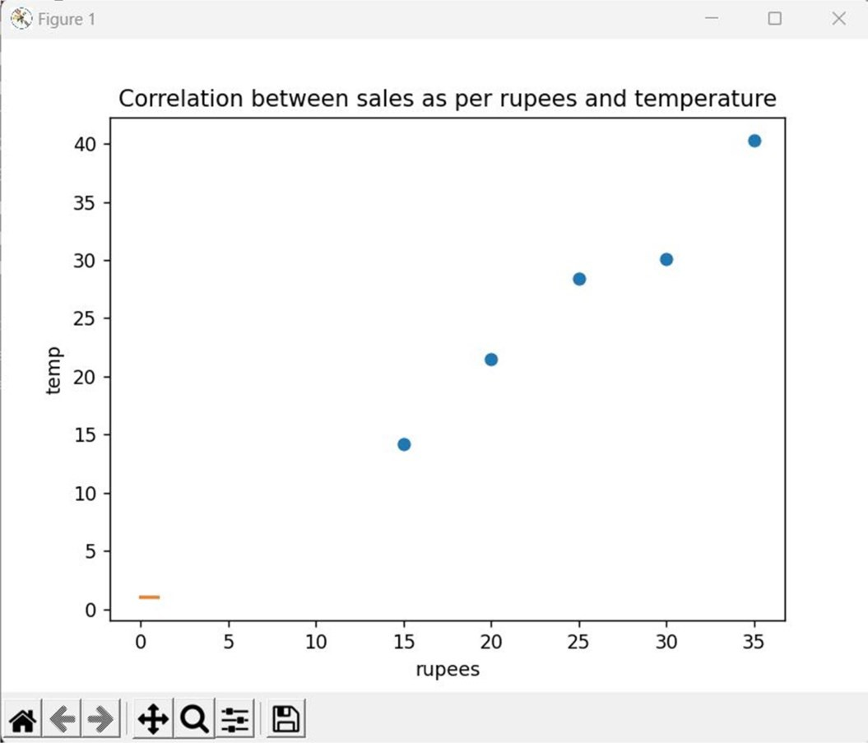

|  |  |
| --- | --- |
| 2 | Plotthecorrelationplotondatasetandvisualizegivinganoverviewofrelationshipsamongdataonirisdata. |

Program:

importpandasaspdimportseabornassnsimportmatplotlib.pyplotaspltdf=pd.read_csv("Iris.csv") rel = df.corr() print(rel)

sns.pairplot(rel)plt.show()

Output:

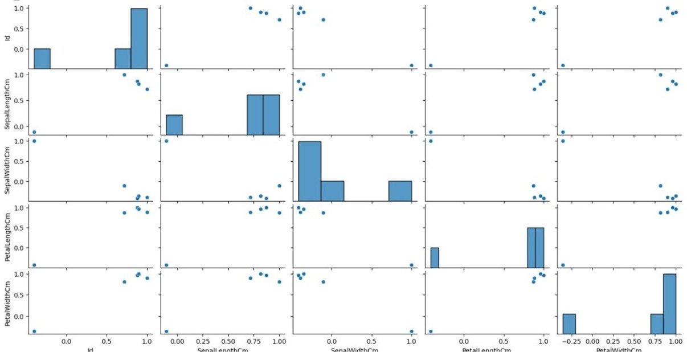

|  |  |
| --- | --- |
| 3 | WriteaPythonprogramtopredictmpg(milespergallon)foracarbasedonvariablewt by applying simple linear regression on 'mtcars' dataset (Use Training data 80% and Testing Data 20%).  Recordtheperformance ofmodelintermsofMAE,MSE,RMSEandR-squaredvalue.  ChangeTrainingdatato70%andTestingData30%,compare&interprettheperformanceofyour model. |

Program:

importpandasaspd

fromseabornimportload_datasetimport statsmodels.formula.api as sm import statsmodels.stats.multicomp as multi

iris=load_dataset("iris")

my_subset=iris[iris["species"].isin(['setosa','virginica'])]

subset_model=sm.ols(formula='sepal_length~C(species)',data=my_subset) print(subset_model.fit().summary()) my_subset.groupby("species").mean() print(my_subset.groupby("species").std())

multi_comp=multi.MultiComparison(iris['sepal_length'],iris['species'])print(multi_comp.tukeyhsd().summary())

Output:

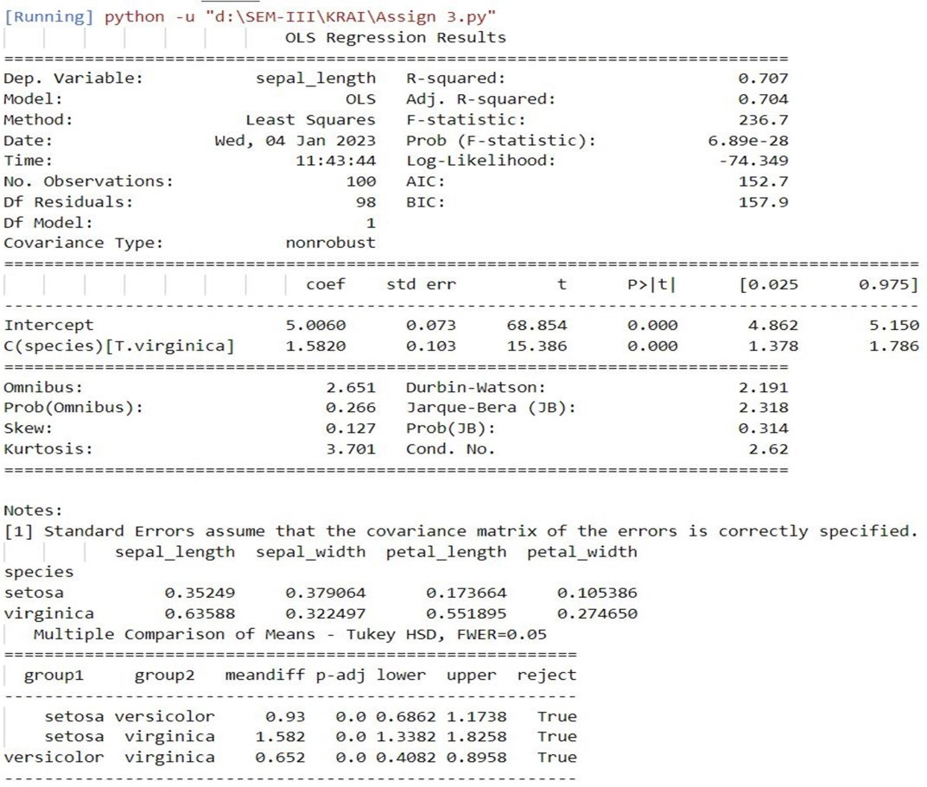

|  |  |
| --- | --- |
| 4 | WriteaPythonprogramtopredictmpg(milespergallon)foracarbasedonvariableswt, cyl & disp by applying multi-linear regression on 'mtcars' dataset (Use Training data80% and Testing Data 20%).  RecordtheperformanceofmodelintermsofMAE,MSE,RMSEandR-squaredvalue. Remove variable disp from the feature set and check the performance again. |

Program:

importnumpyasnpimportmatplotlib.pyplotaspltimportpandasaspd dataset = pd.read_csv('Salary_Data.csv') X =

dataset.iloc[:,:-1].valuesy=dataset.iloc[:,1].values fromsklearn.model_selectionimporttrain_test_split

X_train, X_test, y_train, y_test = train_test_split(X, y, test_size = 1/3, random_state = 0) from sklearn.linear_modelimportLinearRegressionregressor=LinearRegression()regressor.fit(X_train, y_train) y_pred = regressor.predict(X_test) plt.scatter(X_train, y_train, color = 'red') plt.plot(X_train, regressor.predict(X_train), color = 'blue') plt.scatter(X_test, y_test, color =

'red')

plt.plot(X_train,regressor.predict(X_train),color='blue')plt.title('Salary vs Experience (Test set)') plt.xlabel('Years of Experience') plt.ylabel('Salary') plt.show()

|  |  |
| --- | --- |
| 5 | Write a Python program to predict mpg (miles per gallon) for a car based on variables wt, cyl & disp by applying multi-linear regression on 'mtcars' dataset (UseTraining data 80% and Testing Data 20%).  Recordtheperformance ofmodelintermsofMAE,MSE,RMSEandR-squaredvalue.  Replacedispbydratvariableinthefeaturesetandchecktheperformanceagain.Interpret the performance of your model. |

Program:

importnumpyasnpimportmatplotlib.pyplotaspltimportpandasas pd from sklearn.model_selection import train_test_split from sklearn.preprocessing import StandardScaler from sklearn.linear_model import LogisticRegression from sklearn.metrics import confusion_matrix from sklearn.metrics import accuracy_score from matplotlib.colors import ListedColormap dataset = pd.read_csv('DMVWrittenTests.csv') X = dataset.iloc[:, [0, 1]].values y = dataset.iloc[:, 2].values

X_train,X_test,y_train,y_test=train_test_split(X,y,test_size=0.25,random_state=0)sc= StandardScaler()

X_train=sc.fit_transform(X_train)X_test=sc.transform(X_test) classifier = LogisticRegression() classifier.fit(X_train, y_train) y_pred=classifier.predict(X_test)cm=confusion_matrix(y_test, y_pred) print ("Accuracy : ", accuracy_score(y_test, y_pred))

df = pd.DataFrame({'Real Values':y_test, 'PredictedValues':y_pred}) X_set, y_set = X_test, y_test

X1,X2=np.meshgrid(np.arange(start=X_set[:,0].min()-1,stop=X_set[:,0].max()+1,step= 0.01),np.arange(start = X_set[:, 1].min() - 1, stop = X_set[:, 1].max() + 1, step = 0.01))

plt.contourf(X1,X2,classifier.predict(np.array([X1.ravel(),X2.ravel()]).T).reshape(X1.shape),alpha=0.75,cmap

=ListedColormap(('orange', 'green')))

plt.xlim(X1.min(), X1.max()) plt.ylim(X2.min(), X2.max())fori,jinenumerate(np.unique(y_set)):

plt.scatter(X_set[y_set==j,0],X_set[y_set==j,1],c=ListedColormap(('blue','yellow'))(i),label=j) plt.title('Logistic Regression') plt.xlabel('Logistic_Test_1') plt.ylabel('Logistic_Test_2')

plt.legend()plt.show()

Output:

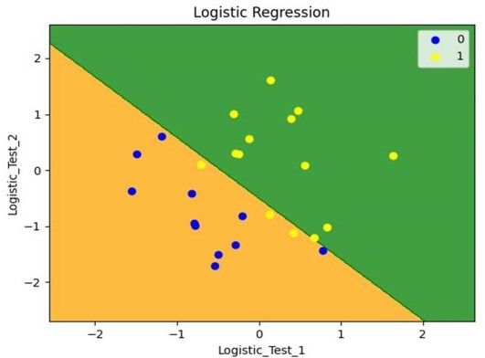

|  |  |
| --- | --- |
| 6 | WriteaPythonprogramtopredictfruit(AppleorOrange)basedonitssize&weightby applying logistic regression on 'apples_and_oranges' dataset (Use Training data 80% And Testing Data 20%).  EvaluatetheperformanceofthemodelusingAccuracyScoremetric,ClassificationReport& Confusion Matrix,AUC ROC score for the model and interpret the model performance. |

Program:

from numpyimport uniquefrom numpyimport where fromsklearn.datasetsimportmake_classificationfrom sklearn.clusterimportKMeansfrommatplotlibimport pyplot

#definedataset

X,_=make_classification(n_samples=1000,n_features=2,n_informative=2,n_redundant=0, n_clusters_per_class=1, random_state=4)

#definethemodel

model=KMeans(n_clusters=2) # fit the model model.fit(X)

#assignaclustertoeachexampleyhat= model.predict(X) # retrieve unique clusters clusters = unique(yhat)

#createscatterplotforsamplesfromeachclusterforclusterin clusters:

#getrowindexesforsampleswiththisclusterrow_ix

=where(yhat==cluster)#createscatterofthese samples

pyplot.scatter(X[row_ix,0],X[row_ix,1]) # show the plot pyplot.show()

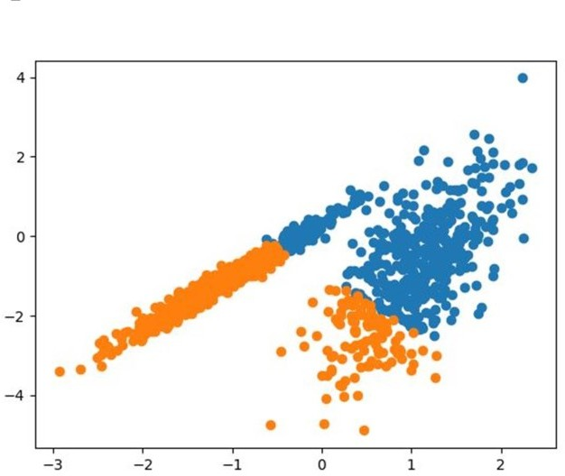Output:

|  |  |
| --- | --- |
| 7 | WriteaPythonprogramtopredictfruit(AppleorOrange)basedonitssize&weight by applying K-Nearest Neighbour (KNN) model on 'apples_and_oranges' dataset (Use Training data 80% and Testing Data 20%).  EvaluatetheperformanceofthemodelusingAccuracyScoremetric,Classification Report & Confusion Matrix,AUC ROC score for the model and interpret the  model performance. |

Program:

from numpyimport uniquefrom numpyimport where fromsklearn.datasetsimportmake_classificationfrom sklearn.cluster import AgglomerativeClustering from matplotlib import pyplot

#definedataset

X,_=make_classification(n_samples=1000,n_features=2,n_informative=2,n_redundant=0, n_clusters_per_class=1, random_state=4)

#definethemodel

model=AgglomerativeClustering(n_clusters=2) # fit model and predict clusters

yhat = model.fit_predict(X) # retrieveuniqueclustersclusters= unique(yhat)

#createscatterplotforsamplesfromeachclusterfor cluster in clusters:

# get row indexes for samples with this cluster row_ix=where(yhat==cluster)#createscatterof these samples

pyplot.scatter(X[row_ix,0],X[row_ix,1]) # show the plot

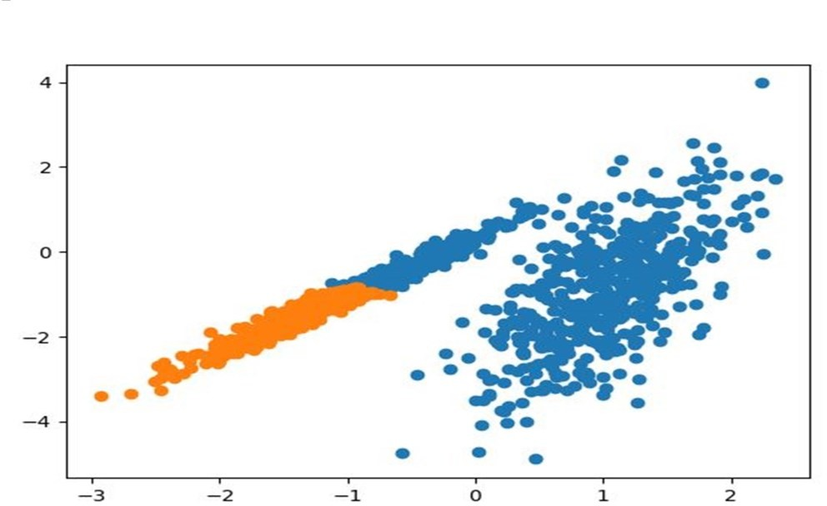pyplot.show() Output:

|  |  |
| --- | --- |
| 8 | WriteaPythonprogramtopredictfruit(AppleorOrange)basedonitssize&weight byapplyingSupportVectorMachine(SVM)modelon'apples_and_oranges'dataset (Use Training data 80% and Testing Data 20%).  EvaluatetheperformanceofthemodelusingAccuracyScoremetric,ClassificationReport& Confusion Matrix,AUC ROC score for the model and interpret the model performance. |

Program:

importpandasaspdimportnumpyasnpimportmatplotlib.pyplotas plt from sklearn import datasets import scipy.cluster.hierarchy as sc import matplotlib.pyplot as plt from sklearn.cluster import AgglomerativeClustering

# Import iris data iris = datasets.load_iris() iris_data = pd.DataFrame(iris.data) iris_data.columns = iris.feature_names iris_data['flower_type'] = iris.target iris_data.head() iris_X = iris_data.iloc[:, [0, 1, 2,3]].valuesiris_Y=iris_data.iloc[:,4].values"""plt.figure(figsize=(10,7))plt.scatter(iris_X[iris_Y==0,0], iris_X[iris_Y== 0, 1],s=100, c='blue',label='Type 1')plt.scatter(iris_X[iris_Y== 1, 0],iris_X[iris_Y== 1,

1],s=100,c='yellow',label='Type2')plt.scatter(iris_X[iris_Y==2,0],iris_X[iris_Y==2,1],s=100, c='green', label='Type 3') plt.legend() plt.show()""" # Plot dendrogram plt.figure(figsize=(20, 7)) plt.title("Dendrograms") # Create dendrogram

sc.dendrogram(sc.linkage(iris_X,method='ward'))

plt.title('Dendrogram') plt.xlabel('Sample index') plt.ylabel('Euclidean distance') cluster = AgglomerativeClustering(n_clusters=3, affinity='euclidean', linkage='ward') cluster.fit(iris_X) labels = cluster.labels_print(labels)plt.figure(figsize=(10,7))plt.scatter(iris_X[labels==0,0],iris_X[labels==0,1],s=

100,c='blue',label='Type1')plt.scatter(iris_X[labels==1,0],iris_X[labels==1,1],s=100,c='yellow',label

='Type2')plt.scatter(iris_X[labels==2,0],iris_X[labels== 2,1],s=100,c='green',label='Type3')plt.legend() plt.show()

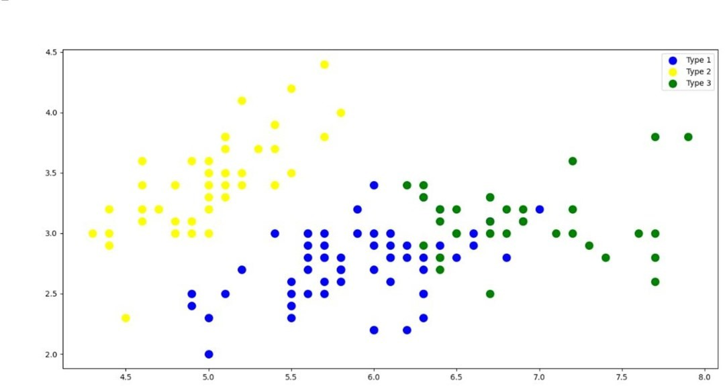Output:

|  |  |
| --- | --- |
| 9 | WriteaPythonprogramtopredictspecies(Setosa,Versicolor,orViriginica)fora  new iris flower based on length & width of its petals and sepals by applying logistic regression model on 'iris' dataset (Use Training data 80% and Testing Data 20%).  EvaluatetheperformanceofthemodelusingAccuracyScoremetric,ClassificationReport& Confusion Matrix,AUC ROC score for the model and interpret the model performance. |

Program:

importpandasaspdimportmatplotlib.pyplotas pltfrom efficient_apriori import apriori

df=pd.read_csv('Market_Basket_Optimisation.csv',encoding='utf-8',header=None) txns=df.values.reshape(-1).tolist() df_list=pd.DataFrame(txns) df_list['Count']=1 txns=df.values.reshape(-1).tolist()

df_list=df_list.groupby(by=[0],as_index=False).count().sort_values(by=['Count'],ascending=True)#count df_list['Percentage'] = (df_list['Count'] /df_list['Count'].sum()) # percentage df_list=df_list.rename(columns={0 : 'Item'}) df_list

plt.figure(figsize=(16,20),dpi=40)plt.ylabel('Item Name') plt.xlabel('Count')

plt.barh(df_list['Item'],width=df_list['Count'],color='r',height=0.9) plt.margins(0.01) plt.show()

Output:

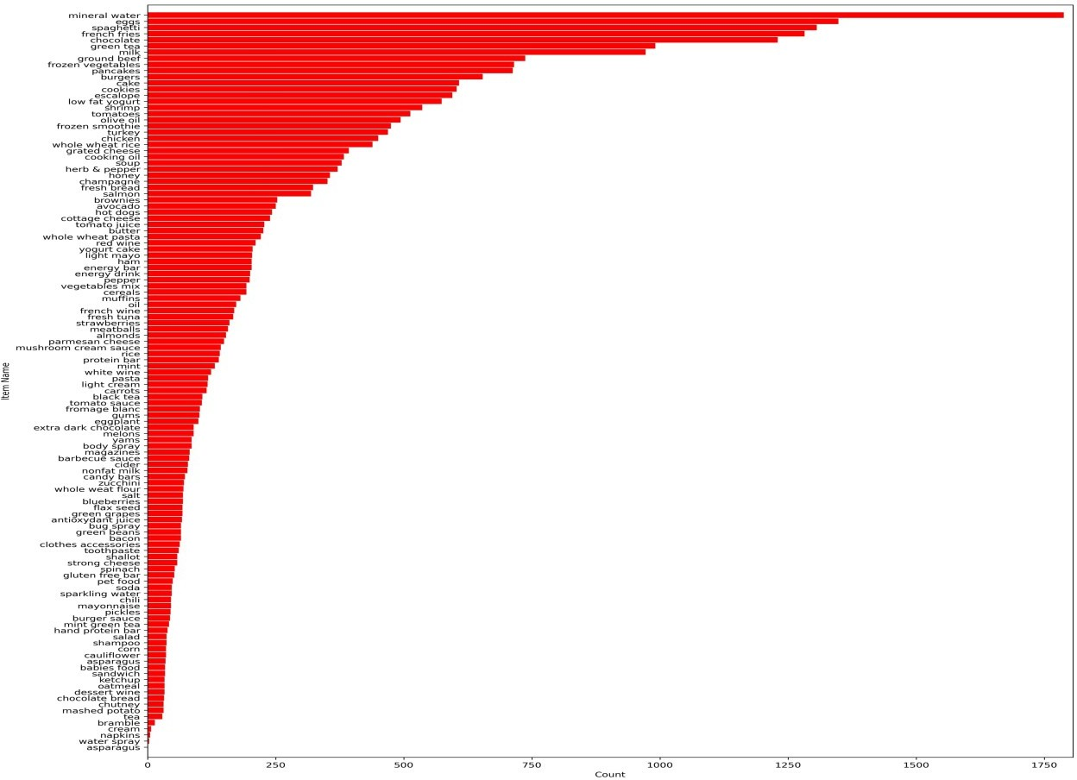

Program:

import pandas as pd import numpy as np import matplotlib.pyplot as plt import seaborn as sns from sklearn.preprocessing import LabelEncoder#for train test splitting from sklearn.model_selection import train_test_split#for decision tree object from sklearn.tree import DecisionTreeClassifier#for checking testing results from sklearn.metrics import classification_report, confusion_matrix#for visualizing tree fromsklearn.treeimportplot_treedf=sns.load_dataset('iris')df.head()df.info()df.shapedf.isnull().any() sns.pairplot(data=df, hue = 'species') sns.heatmap(df.corr()) target = df['species'] df1 = df.copy() df1 = df1.drop('species', axis =1) X = df1 print(target) le = LabelEncoder() target = le.fit_transform(target) print(target) y = target

X_train,X_test,y_train,y_test=train_test_split(X,y,test_size=0.2,random_state=42)print("Training split input- ", X_train.shape) print("Testing split input- ", X_test.shape) dtree=DecisionTreeClassifier() dtree.fit(X_train,y_train) print('Decision Tree Classifier Created') y_pred = dtree.predict(X_test) print("Classification report - \n", classification_report(y_test,y_pred))

cm=confusion_matrix(y_test,y_pred)

plt.figure(figsize=(5,5))sns.heatmap(data=cm,linewidths=.5,annot=True,square=True,cmap= 'Blues') plt.ylabel('Actual label') plt.xlabel('Predictedlabel') all_sample_title = 'Accuracy Score:

{0}'.format(dtree.score(X_test,y_test))plt.title(all_sample_title,size=15) dec_tree = plot_tree(decision_tree=dtree, feature_names = df1.columns,

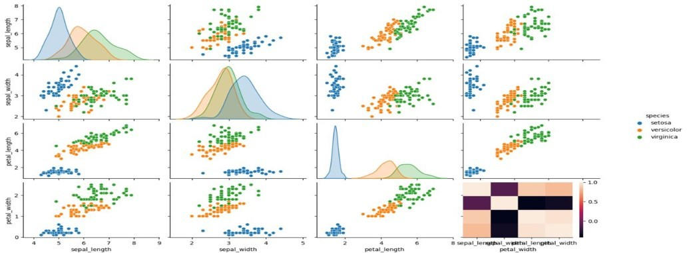class_names=["setosa","vercicolor","verginica"],filled=True,precision=4,rounded=True)plt.show() Output:

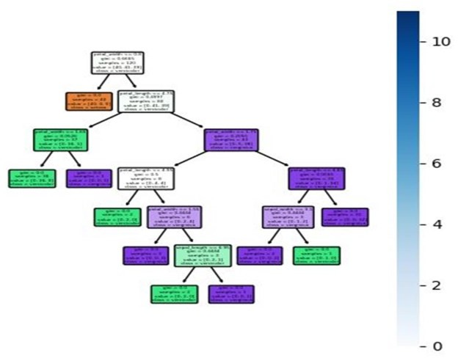

Program:

fromsklearn.datasetsimportload_iris iris = load_iris()

#storethefeaturematrix(X)andresponsevector(y)X=iris.datay

=iris.target

#splittingXandyintotrainingandtestingsetsfrom sklearn.model_selection import train_test_split

X_train,X_test,y_train,y_test=train_test_split(X,y,test_size=0.3,random_state=3) # training the model on training set from

sklearn.naive_bayesimportGaussianNBgnb= GaussianNB() gnb.fit(X_train, y_train)

#makingpredictionsonthetestingsety_pred= gnb.predict(X_test)

#comparingactualresponsevalues(y_test)withpredictedresponsevalues(y_pred)fromsklearnimport metrics

print("GaussianNaiveBayesmodelaccuracy(in%):",metrics.accuracy_score(y_test,y_pred)*100)

Output:

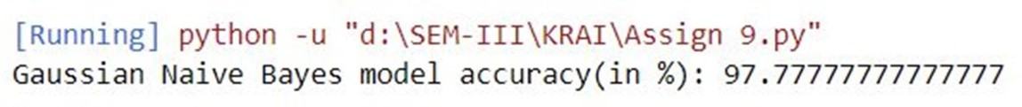

Program:

importpandasaspd

fromsklearn.model_selectionimporttrain_test_split from sklearn.svm import SVC dataset_url = "Fish.csv" fish = pd.read_csv(dataset_url)

fish

fish= pd.read_csv(dataset_url)

X=fish.drop(['Species'],axis='columns')y=fish.Species

X_train,X_test,y_train,y_test=train_test_split(X,y,test_size=0.2) model = SVC(kernel = 'linear', C = 1) model.fit(X_train,

y_train)svm_pred=model.predict(X_test)accuracy= model.score(X_test, y_test) print("SVC Clacification:

{0}".format(accuracy))

OutPut:

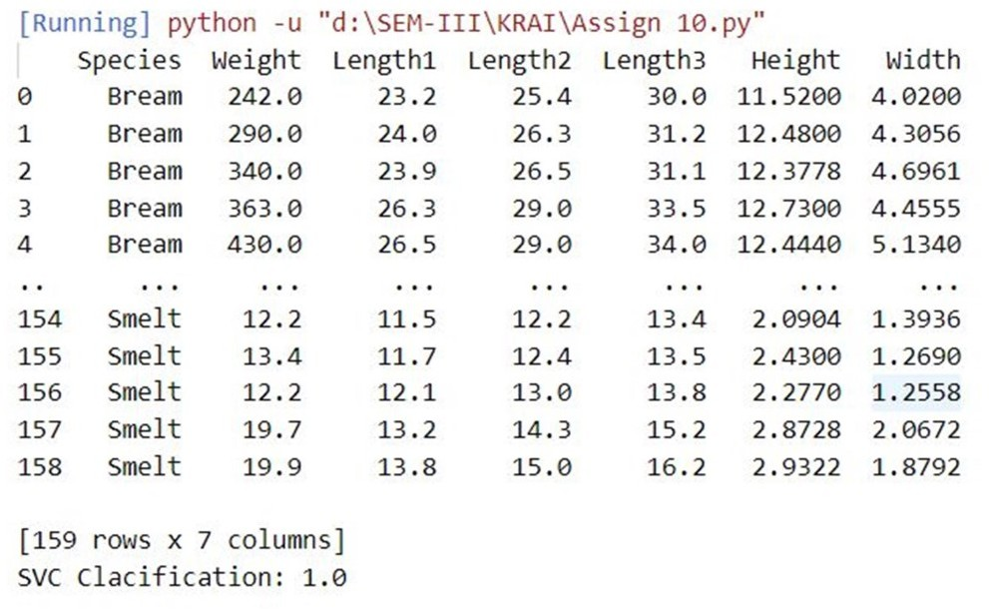

Program:

frommonkeylearnimportMonkeyLearn

ml = MonkeyLearn('4e1d801fabd0088150b8317b339f5665bdfb9972') data=['Veryhelpfulandfriendlystaff.','Bedwasextremelycomfortable.'] model_id = 'cl_TKb7XmdG'

result=ml.classifiers.classify(model_id,data)print(result.body) Output:

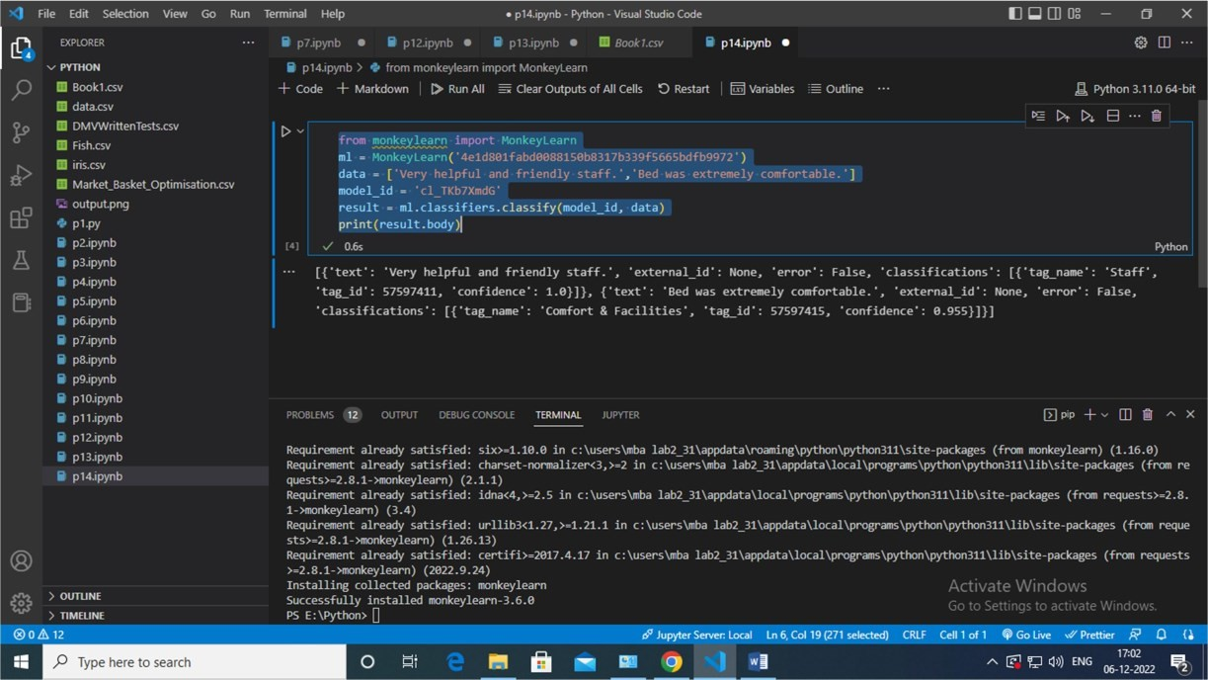

Program:

importmatplotlib.pyplotaspltfromkneedimportKneeLocator from sklearn.datasets import make_blobs from sklearn.cluster import KMeans from sklearn.metrics import silhouette_score from sklearn.preprocessing import StandardScaler features, true_labels = make_blobs(

n_samples=200,centers=3, cluster_std=2.75, random_state=42

)

features[:5]scaler=StandardScaler()

scaled_features=scaler.fit_transform(features)scaled_features[:5]

kmeans_kwargs={ "init": "random", "n_init": 10,

"max_iter":300,

"random_state":42,

}sse =[]forkinrange(1,11):

kmeans=KMeans(n_clusters=k,**kmeans_kwargs) kmeans.fit(scaled_features)

sse.append(kmeans.inertia_) plt.style.use("fivethirtyeight")plt.plot(range(1, 11), sse) plt.xticks(range(1, 11)) plt.xlabel("Number of Clusters") plt.ylabel("SSE") plt.show() silhouette_coefficients = []

forkinrange(2,11):

kmeans=KMeans(n_clusters=k,**kmeans_kwargs) kmeans.fit(scaled_features)

score = silhouette_score(scaled_features, kmeans.labels_) silhouette_coefficients.append(score) plt.style.use("fivethirtyeight") plt.plot(range(2,11),silhouette_coefficients)plt.xticks(range(2,11)) plt.xlabel("NumberofClusters")plt.ylabel("SilhouetteCoefficient") plt.show()

fromsklearn.clusterimportDBSCANfromsklearn.datasets import make_moons from sklearn.metrics import adjusted_rand_score features, true_labels = make_moons( n_samples=250, noise=0.05, random_state=42

)

scaled_features=scaler.fit_transform(features)kmeans= KMeans(n_clusters=2) dbscan = DBSCAN(eps=0.3) kmeans.fit(scaled_features) dbscan.fit(scaled_features) kmeans_silhouette = silhouette_score(scaled_features, kmeans.labels_

).round(2)

dbscan_silhouette=silhouette_score(scaled_features,dbscan.labels_

).round(2)kmeans_silhouette

Output:

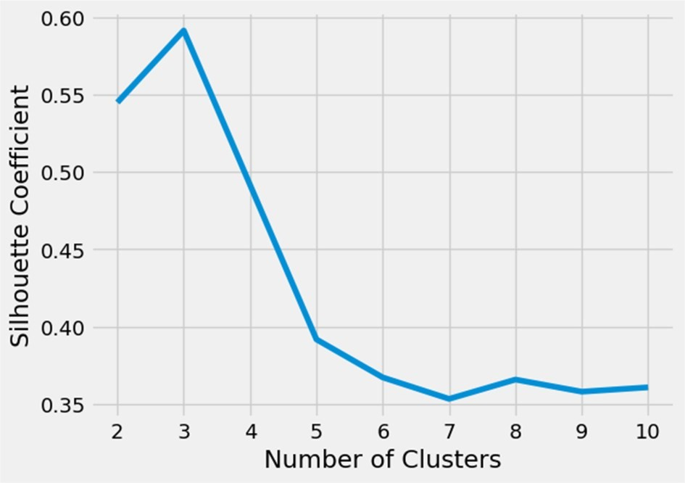

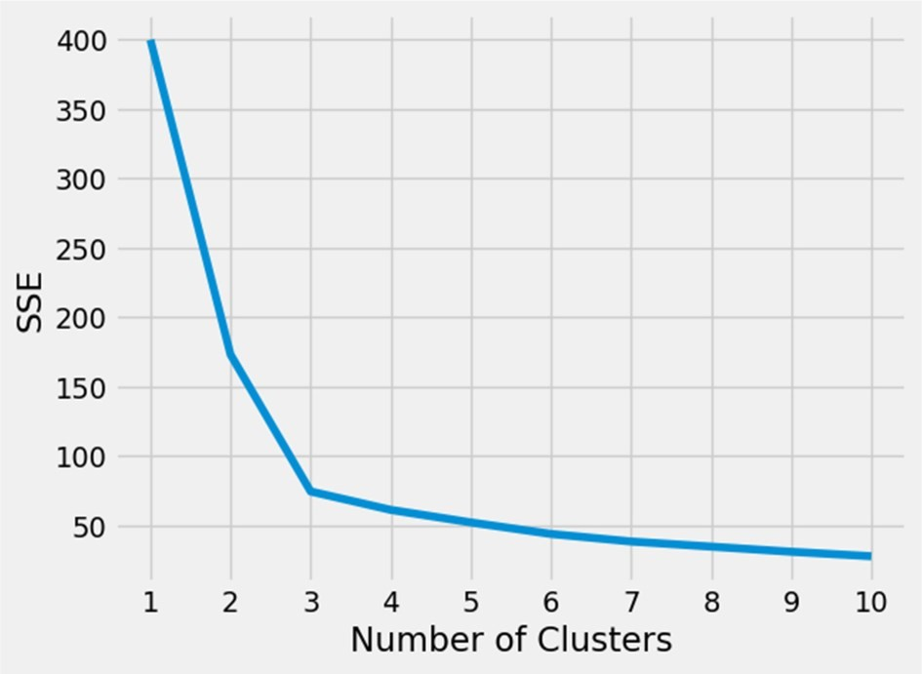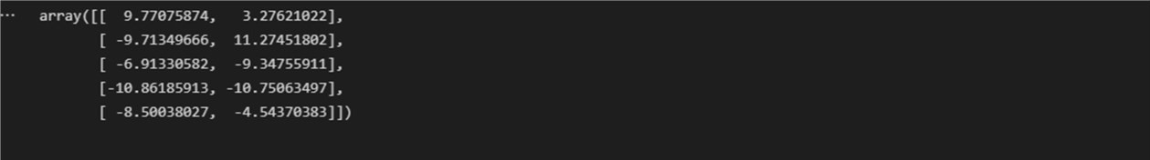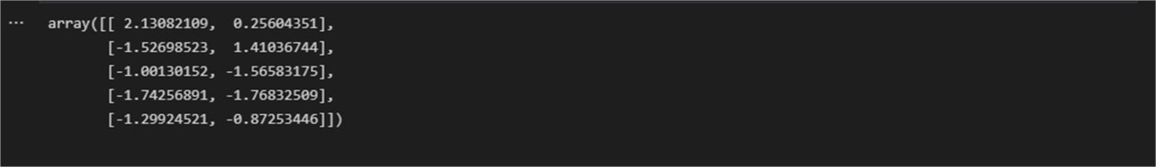

Program:

import numpy as np classNeuralNetwork():def init(self,learning_rate): self.weights=np.array([np.random.randn(),np.random.randn()])self.bias= np.random.randn()

self.learning_rate=learning_rate

def_sigmoid(self,x):

return1/(1+np.exp(-x))

def_sigmoid_deriv(self,x):

returnself._sigmoid(x)*(1-self._sigmoid(x))

defpredict(self,input_vector):

layer_1 = np.dot(input_vector, self.weights) + self.bias layer_2= self._sigmoid(layer_1) prediction = layer_2 return prediction

def_compute_gradients(self,input_vector,target):

layer_1 = np.dot(input_vector, self.weights) + self.bias layer_2= self._sigmoid(layer_1) prediction = layer_2

derror_dprediction = 2 * (prediction - target) dprediction_dlayer1= self._sigmoid_deriv(layer_1) dlayer1_dbias = 1

dlayer1_dweights = (0 * self.weights) + (1 *input_vector) derror_dbias=( derror_dprediction * dprediction_dlayer1 *dlayer1_dbias

)

derror_dweights=(

derror_dprediction*dprediction_dlayer1*dlayer1_dweights

)

returnderror_dbias,derror_dweights

def_update_parameters(self,derror_dbias,derror_dweights):

self.bias = self.bias - (derror_dbias *self.learning_rate) self.weights = self.weights - ( derror_dweights * self.learning_rate) deftrain(self,input_vectors, targets, iterations):

cumulative_errors = [] forcurrent_iterationin range(iterations):

random_data_index=np.random.randint(len(input_vectors)) input_vector = input_vectors[random_data_index] target = targets[random_data_index]

derror_dbias, derror_dweights =self._compute_gradients( input_vector, target ) self._update_parameters(derror_dbias,derror_dweights) ifcurrent_iteration%100==0:

cumulative_error = 0 fordata_instance_indexin range(len(input_vectors)): data_point

=input_vectors[data_instance_index] target = targets[data_instance_index] prediction=self.predict(data_point) error = np.square(prediction - target) cumulative_error = cumulative_error + error

cumulative_errors.append(cumulative_error) returncumulative_errors

learning_rate=0.1

neural_network=NeuralNetwork(learning_rate)

importmatplotlib.pyplotasplt input_vectors = np.array([

[3, 1.5],

[2, 1],

[4, 1.5],

[3, 4],

[3.5,0.5],

[2, 0.5],

[5.5,1],

[1, 1],

]

)

targets=np.array([0,1,0,1,0,1,1,0])

learning_rate=0.1

neural_network=NeuralNetwork(learning_rate)

training_error=neural_network.train(input_vectors,targets,10000) plt.plot(training_error) plt.xlabel("Iteons")

plt.ylabel("Errorforratialltraininginstances")plt.savefig("cumulative_error.png")

Output:

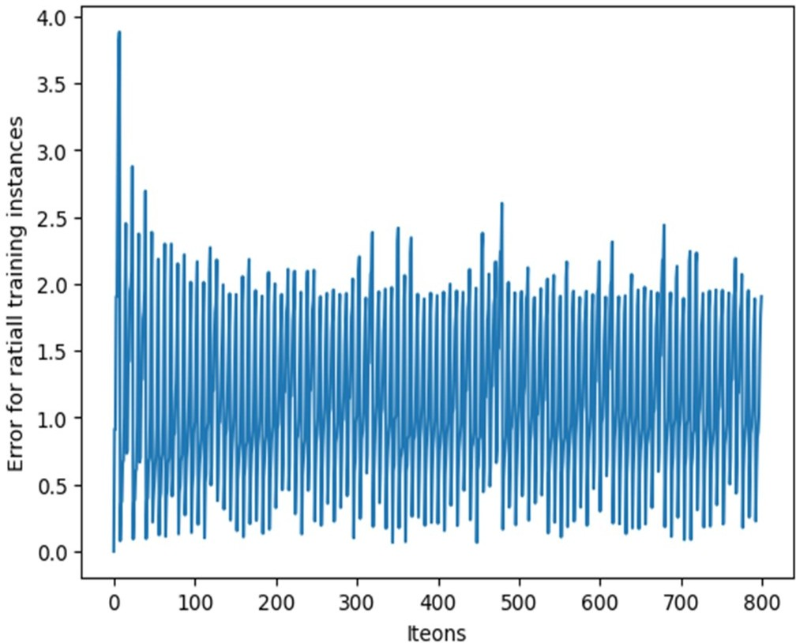

Program:

importmath

importmatplotlib.pyplotaspltfrommatplotlib.patchesimportWedgedef draw_neural_net(ax, left, right, bottom, top, layer_sizes):

n_layers=len(layer_sizes)

v_spacing = (top - bottom)/float(max(layer_sizes)) h_spacing= (right - left)/float(len(layer_sizes) - 1) for n, layer_size in enumerate(layer_sizes):

layer_top = v_spacing*(layer_size - 1)/2. + (top +bottom)/2. formin range(layer_size):

circle=plt.Circle((n*h_spacing+left,layer_top-m*v_spacing),v_spacing/4.,color='w',ec='k',zorder=4) ax.add_artist(circle)

for n, (layer_size_a, layer_size_b) in enumerate(zip(layer_sizes[:-1], layer_sizes[1:])): layer_top_a= v_spacing*(layer_size_a - 1)/2. + (top +bottom)/2. layer_top_b = v_spacing*(layer_size_b - 1)/2. + (top +bottom)/2.

for m in range(layer_size_a): for o in range(layer_size_b): line = plt.Line2D([n*h_spacing+left,(n+1)*h_spacing+ left],[layer_top_a - m*v_spacing,layer_top_b - o*v_spacing], c='k')

ax.add_artist(line)

for n, (layer_size) in enumerate(layer_sizes): layer_top=v_spacing* (layer_size - 1) / 2. + (top +bottom) / 2. for m in range(layer_size):

center = (n * h_spacing + left, layer_top - m *v_spacing) radius= v_spacing / 4. if n > 0:

wedge_left =Wedge(center, r=radius, theta1=90,theta2=270, color='w',fc='g', ec='k', zorder=4) wedge_right=Wedge(center,r=radius,theta1=270,theta2=90,color='w',fc='r',ec='k',zorder=4) ax.add_artist(wedge_left)

ax.add_artist(wedge_right) else:

circle = plt.Circle(center, radius, color='w',ec='k', zorder=4) ax.add_artist(circle)fig=plt.figure(figsize=(12,12))ax=fig.gca()ax.axis('off') draw_neural_net(ax, .1, .9, .1, .9, [4, 7, 2]) fig.savefig('nn.png')

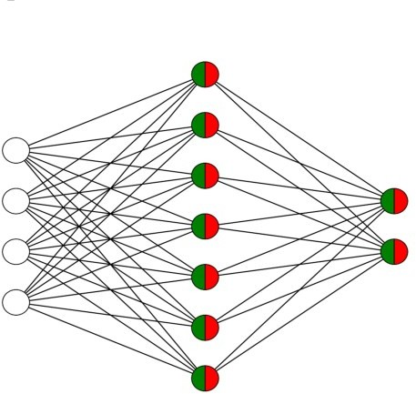Output:

Program:

importosimportsysimport cv2

importnumpyasnp

input_f='letter.data'img_resize_factor

= 12 start, end = 6, -1 height, width = 16, 8 with open(input_f, 'r') as f: for line in f.readlines():

data = np.array([255*float(x) for x in line.split('\t')[start:end]]) img= np.reshape(data, (height, width))

img_scaled = cv2.resize(img, None, fx=img_resize_factor, fy=img_resize_factor) print(line) cv2.imshow('Img', img_scaled)

c = cv2.waitKey() ifc== 27: break

Output:

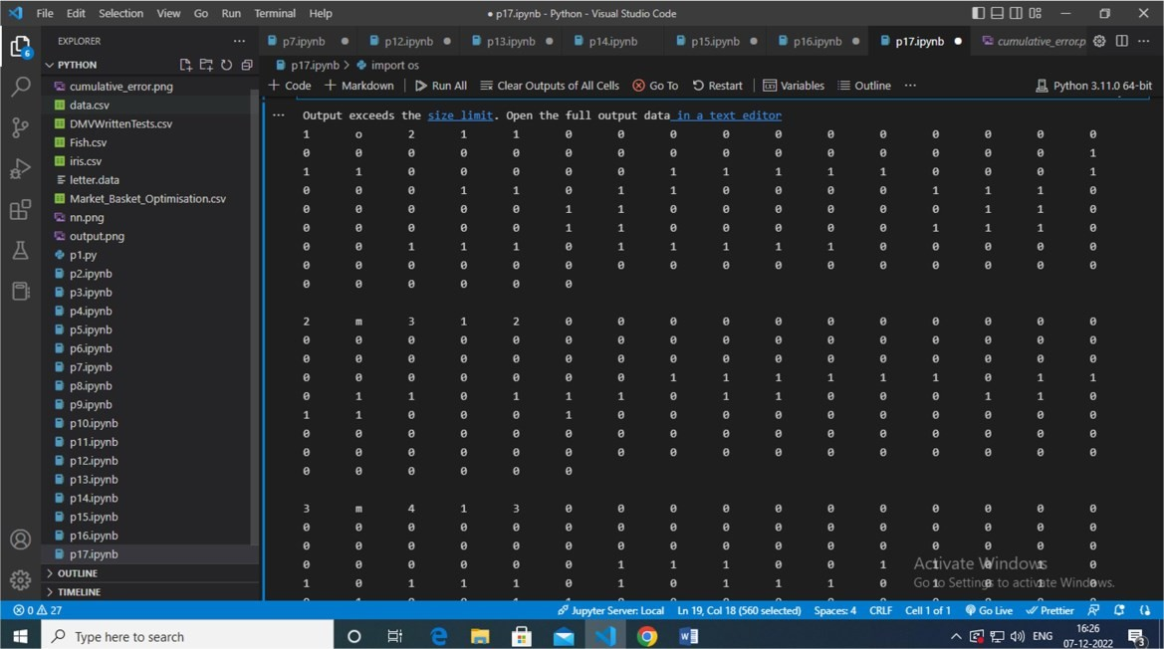

Program:

importcv2importnumpyasnp import os

fromrandomimportshuffle from tqdm import tqdm

#Download the images of dogs and cats from the following URL(https://[www.kaggle.com/c/dogs-vs-cats-redux-kernels-edition/data)](http://www.kaggle.com/c/dogs-vs-cats-redux-kernels-edition/data))andextractit

TRAIN_DIR='E:/Python/train' TEST_DIR = 'E:/Python/test' IMG_SIZE = 50

LR= 1e-3

MODEL_NAME='dogvscats-{}-{}.model'.format(LR,'6conv-basic-video') def label_img(img):

word_label=img.split('.')[-3] ifword_label

=='cat':return[1,0]

elifword_label=='dog':return[0,1]

def create_train_data(): training_data = [] forimgin tqdm(os.listdir(TRAIN_DIR)): label = label_img(img)

path=os.path.join(TRAIN_DIR,img)

img=cv2.resize(cv2.imread(path,cv2.IMREAD_GRAYSCALE),(IMG_SIZE,IMG_SIZE)) training_data.append([np.array(img), np.array(label)]) shuffle(training_data)

np.save('train_data.npy', training_data) return training_data

def process_test_data(): testing_data = [] forimgin

tqdm(os.listdir(TEST_DIR)): path = os.path.join(TEST_DIR,img) img_num= img.split('.')[0]

img=cv2.resize(cv2.imread(path,cv2.IMREAD_GRAYSCALE),(IMG_SIZE,IMG_SIZE)) testing_data.append([np.array(img), img_num])

np.save('test_data.npy',testing_data) returntesting_data import tflearn

fromtflearn.layers.convimportconv_2d,max_pool_2dfromtflearn.layers.core

importinput_data,dropout,fully_connectedfromtflearn.layers.estimatorimport regression

convnet=input_data(shape=[None,IMG_SIZE,IMG_SIZE,1],name='input')

convnet=conv_2d(convnet,32,2,activation='relu') convnet = max_pool_2d(convnet, 2)

convnet=conv_2d(convnet,64,2,activation='relu') convnet = max_pool_2d(convnet, 2)

convnet=conv_2d(convnet,32,2,activation='relu') convnet = max_pool_2d(convnet, 2)

convnet=conv_2d(convnet,64,2,activation='relu') convnet = max_pool_2d(convnet, 2)

convnet=conv_2d(convnet,32,2,activation='relu') convnet = max_pool_2d(convnet, 2)

convnet=conv_2d(convnet,64,2,activation='relu') convnet = max_pool_2d(convnet, 2)

convnet=fully_connected(convnet,1024,activation='relu')convnet= dropout(convnet, 0.8)

convnet=fully_connected(convnet,2,activation='softmax')convnet= regression(convnet, optimizer='adam', learning_rate=LR, loss='categorical_crossentropy', name='targets')

model=tflearn.DNN(convnet,tensorboard_dir='log') if os.path.exists('{}.meta'.format(MODEL_NAME)):

model.load(MODEL_NAME) print('modelloaded!')

train = train_data[:-500] test = train_data[-500:]X=np.array([i[0]fori in train]).reshape(-1, IMG_SIZE, IMG_SIZE, 1)

Y=[i[1]fori intrain]

test_x=np.array([i[0]foriintest]).reshape(-1,IMG_SIZE,IMG_SIZE,1)test_y=[i[1]foriin test]

model.fit({'input':X},{'targets':Y},n_epoch=5,validation_set=({'input':test_x},{'targets': test_y}),

snapshot_step=500,show_metric=True,run_id=MODEL_NAME)

model.save(MODEL_NAME)

#tensorboard--logdir=/home/ngacha/MachineLearning/log

importmatplotlib.pyplotasplt#test_data= process_test_data()

test_data=np.load('test_data.npy') fig = plt.figure()

fornum,datainenumerate(test_data[:12]): img_num = data[1]

img_data=data[0]

y = fig.add_subplot(3,4,num+1) orig = img_data data=img_data.reshape(IMG_SIZE,IMG_SIZE,1)

model_out=model.predict([data])[0]

if np.argmax(model_out) == 1: str_label='Dog' else:str_label= 'Cat'

y.imshow(orig, cmap='gray') plt.title(str_label) y.axes.get_xaxis().set_visible(False)

y.axes.get_yaxis().set_visible(False)plt.show()

with open('submission-file.csv', 'w') as f: f.write('id,label\n')withopen('submission-file.csv','w') as f:

fordataintqdm(test_data):

img_num = data[1] img_data=data[0] orig = img_data

data = img_data.reshape(IMG_SIZE, IMG_SIZE, 1) model_out= model.predict([data])[0]

f.write('{},{}\n'.format(img_num,model_out[1]))

Output:

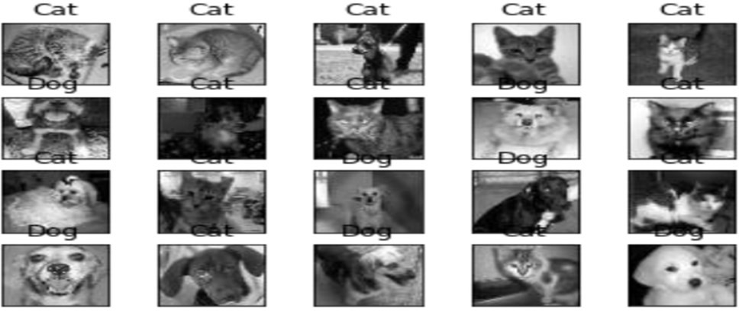

Program:

%load_extautoreload%autoreload2

fromIPython.core.interactiveshellimportInteractiveShell from IPython.display import HTML InteractiveShell.ast_node_interactivity = 'all'

importwarnings

warnings.filterwarnings('ignore', category = RuntimeWarning) warnings.filterwarnings('ignore',category=UserWarning)importpandasaspd import numpy as np from utils import *

data=pd.read_csv('neural_network_patent_query.csv')data.head()

Output:

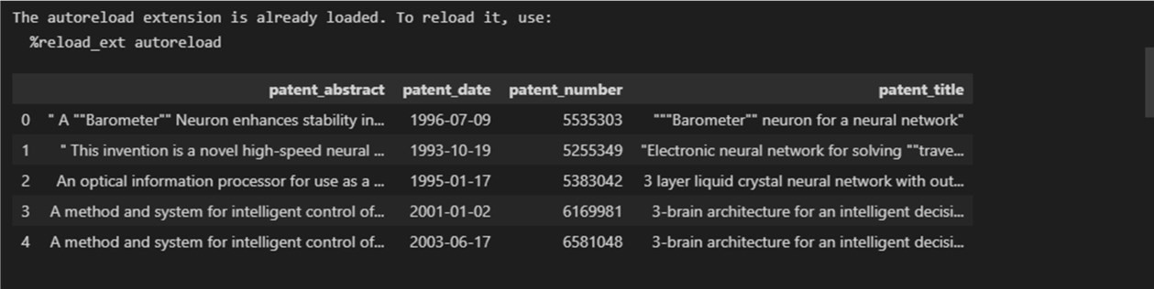

Program:

fromkeras.modelsimportSequential,load_model

from keras.layers import LSTM, Dense, Dropout, Embedding,Masking, Bidirectional from tensorflow.keras.optimizersimportAdamfromtensorflow.keras.utilsimportplot_modelmodel= Sequential() model.add(Embedding(

input_dim=len(word_idx) + 1, output_dim=100,weights=None, trainable=True))

model.add(

LSTM(64,return_sequences=False,dropout=0.1,recurrent_dropout=0.1)

)

model.add(Dense(64, activation='relu')) model.add(Dropout(0.5)) model.add(Dense(len(word_idx) + 1, activation='softmax')) model.compile( optimizer='adam', loss='categorical_crossentropy',metrics=['accuracy']) model.summary()

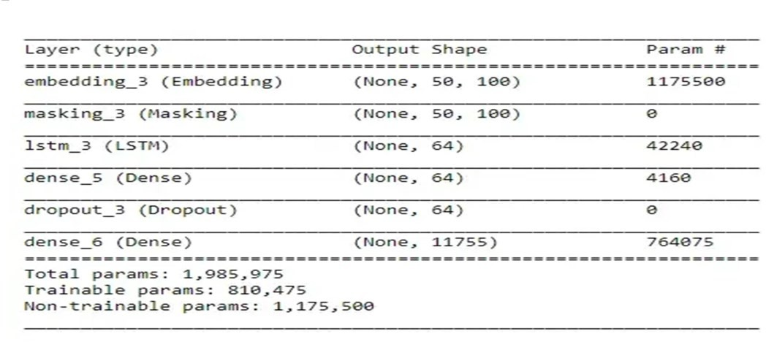Output:

Program:

importnumpyasnpimportmatplotlib.pyplotaspltimportkerasfromkeras.layersimport Input, Dense, Reshape, Flatten, Dropout from keras.layers import BatchNormalization, Activation,ZeroPadding2D from keras.layers import LeakyReLU from keras.layers.convolutional import UpSampling2D, Conv2D from keras.models import Sequential, Model

fromtensorflow.keras.optimizersimportAdam,SGD

(X, y), (_, _) = keras.datasets.cifar10.load_data() X = X[y.flatten()==8]image_shape=(32,32,3)latent_dimensions

=100defbuild_generator():model=Sequential()

model.add(Dense(128*8*8,activation="relu",input_dim=latent_dimensions))

model.add(Reshape((8,8,128)))model.add(UpSampling2D())

model.add(Conv2D(128,kernel_size=3,padding="same"))model.add(BatchNormalization(momentum=0.78)) model.add(Activation("relu"))model.add(UpSampling2D())

model.add(Conv2D(64,kernel_size=3,padding="same"))model.add(BatchNormalization(momentum=0.78)) model.add(Activation("relu"))

model.add(Conv2D(3,kernel_size=3,padding="same")) model.add(Activation("tanh"))noise = Input(shape=(latent_dimensions,))image=model(noise)

return Model(noise, image) def build_discriminator():model=Sequential()

model.add(Conv2D(32,kernel_size=3,strides=2,input_shape=image_shape,padding="same "))

model.add(LeakyReLU(alpha=0.2))model.add(Dropout(0.25)) model.add(Conv2D(64,kernel_size=3,strides=2,padding="same"))

model.add(ZeroPadding2D(padding=((0,1),(0,1))))model.add(BatchNormalization(momentum=0.82)) model.add(LeakyReLU(alpha=0.25))model.add(Dropout(0.25))

model.add(Conv2D(128,kernel_size=3,strides=2,padding="same")) model.add(BatchNormalization(momentum=0.82)) model.add(LeakyReLU(alpha=0.2))model.add(Dropout(0.25)) model.add(Conv2D(256, kernel_size=3, strides=1,padding="same")) model.add(BatchNormalization(momentum=0.8)) model.add(LeakyReLU(alpha=0.25))model.add(Dropout(0.25)) model.add(Flatten())

model.add(Dense(1,activation='sigmoid'))image= Input(shape=image_shape)

validity=model(image)

returnModel(image,validity)def display_images():r, c = 4,4

noise=np.random.normal(0,1,(r*c,latent_dimensions))generated_images= generator.predict(noise)generated_images = 0.5 * generated_images + 0.5

fig,axs=plt.subplots(r,c)

count = 0for i in range(r): forjinrange(c): axs[i,j].imshow(generated_images[count,:,:,]) axs[i,j].axis('off')

count+=1

plt.show() plt.close()

discriminator = build_discriminator() discriminator.compile(loss='binary_crossentropy',optimizer=Adam(0.0002,0.5),metrics=['acc uracy']) discriminator.trainable = False generator = build_generator() z = Input(shape=(latent_dimensions,)) image = generator(z) valid = discriminator(image) combined_network = Model(z, valid) combined_network.compile(loss='binary_crossentropy',optimizer=Adam(0.0002,0.5)) num_epochs=15000 batch_size=32 display_interval=2500

losses=[]X=(X/127.5) -1.

valid=np.ones((batch_size,1))valid+=0.05* np.random.random(valid.shape)

fake=np.zeros((batch_size,1))fake+=0.05* np.random.random(fake.shape) for epoch in range(num_epochs):

index=np.random.randint(0,X.shape[0],batch_size)images=X[index]

noise = np.random.normal(0, 1, (batch_size,latent_dimensions))generated_images = generator.predict(noise)discm_loss_real =discriminator.train_on_batch(images, valid) discm_loss_fake=discriminator.train_on_batch(generated_images,fake)discm_loss=0.5

*np.add(discm_loss_real,discm_loss_fake)genr_loss

=combined_network.train_on_batch(noise,valid)ifepoch%display_interval==6: display_images()

Output:

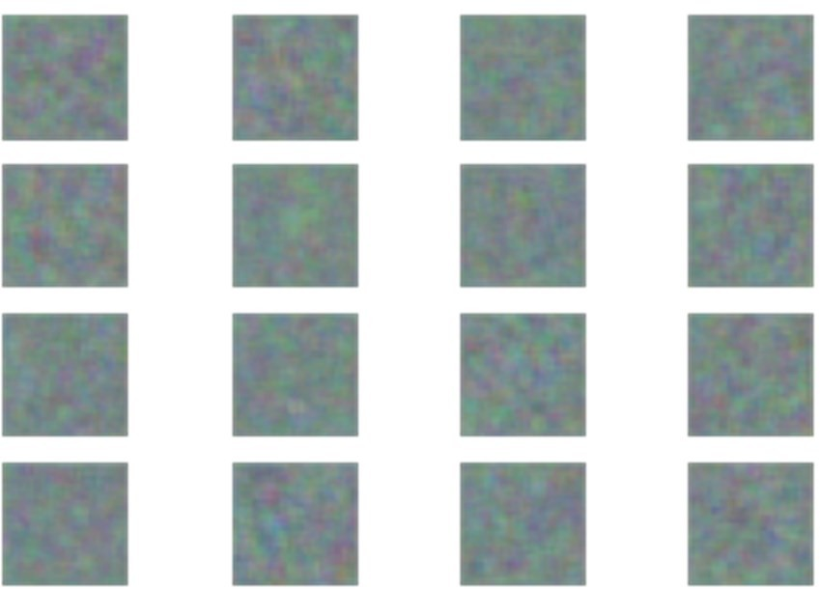

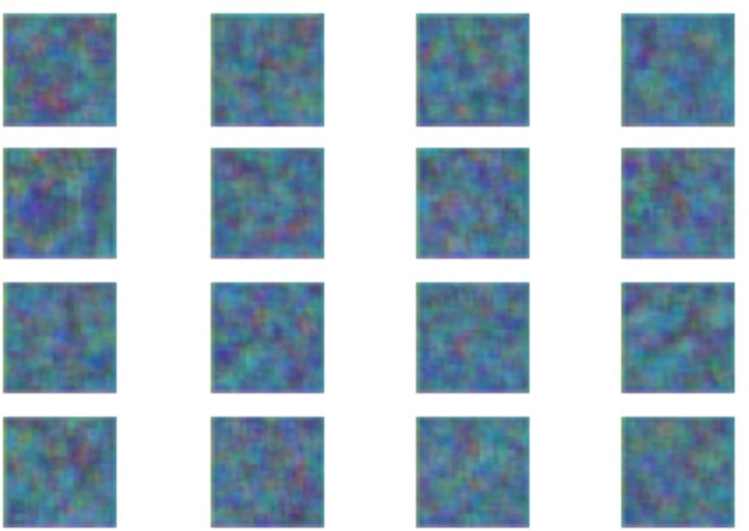

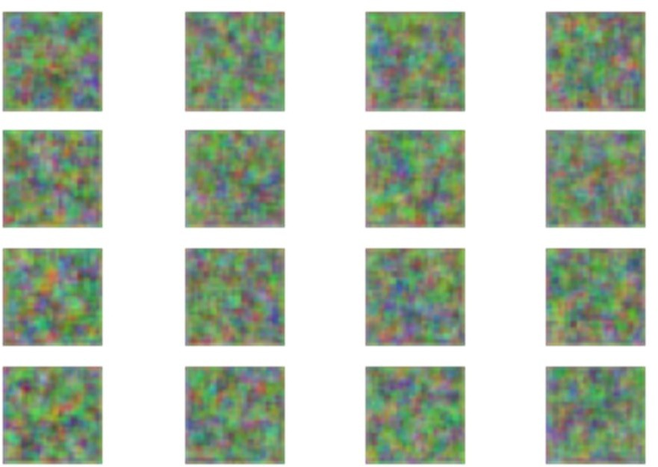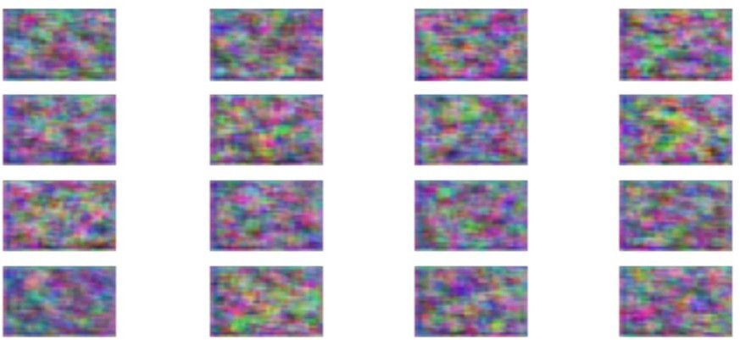

Program:

importm3u8importrequests

from bs4 import BeautifulSoup from tqdm import tqdm_notebook as tqdm import subprocess import requestschunk_size=256sess=requests.session()

ganna_url="https://gaana.com/album/ek-love-ya-original-motionpicture-soundtrack"bob_ganna_url= "https://gaana.com/d0d959d9-fac9-4f38-ad6fa80fc09a468f" log_sing = "?sign=1646556464- Zi7mUDtXYR-0-32a0f29f4bf3977b05ade364f1cbe442" m3File1

="https://vodhlsgaana.akamaized.net/hls/72/4992872/39791107/96/hdntl=exp=1646643931~a cl=%2f*~data=hdntl~hmac=735cd0c11a600b98f7fd283dce25dfaab0f5c006e5fea07ef50cdcfd d525960b/index.m3u8"m3File=m3File1+log_singr=sess.get(m3File,stream=True)m3u8_master= m3u8.loads(r.text)

m3u8_master

playlist_uri=m3u8_master.data['segments']

main_url="https://streamcdn.gaana.com/songs/67/5206667/40781248/40781248_96.mp4/" # playlist_url = main_url + playlist_uri # r =

requests.get(playlist_url)withopen('soung1.ts','wb') as f:

forsegmentinplaylist_uri:

uri = segment['uri'] url = main_url + uri r=requests.get(url) f.write(r.content)

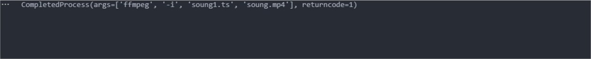subprocess.run(['ffmpeg', '-i','soung1.ts','soung.mp4'],shell=True) Output:

